Victoria Mihojevich-Stratton -July 28, 2022
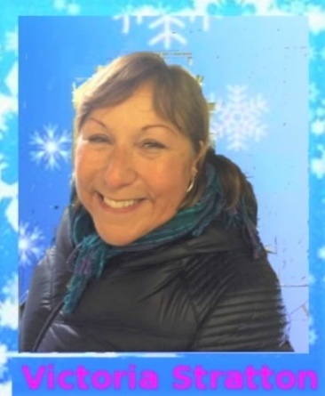
7th test level in figures and freestyle. Principal skater in Ice Capades. Also skated in Ice Follies and Las Vegas on Ice. Been teaching skating for over 30 years. Coached 2 Danish National Champions through Gold Tests. Coached skaters at European Championships and Scandinavian Championships. Choreographed program for Danish National Champion for World Championships.

