**Charlotte Hoecker – Sept. 15 2021**

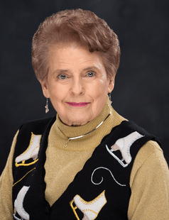Charlotte Tilden Hoecker (Char). Char passed away September 15, 2021. Charlotte was born in Providence RI on March 1, 1929 and resided there until the age of four when her family moved to Evanston Ill.

After high school Charlotte worked in retail in Chicago and was a member of the Chicago Skating Club. Through a connection at the skating club Charlotte was introduced to the manager of the Ice Cycles skating show. Ice Cycles was a joint venture of the Ice Capades and Shipstad and Johnson Ice Follies. Charlotte was invited to skate in the show’s chorus for nine months as they traveled around North America.

Charlotte married Raymond (Ray) Hoecker and had four children. Charlotte and Ray’s family lived in Evanston, Illinois; Dallas, Texas; Crystal Lake, Illinois; Yarmouth, Maine and finally settled in Wausau WI in 1979. She began teaching skating in her back yard while living in Illinois. Eventually she approached the town of Crystal Lake about opening a skating rink on the lakefront. When Charlotte and Ray moved to Maine, she continued skating at the Riverside Ice Arena and at Bowdoin College’s ice rink. She began taking ice dancing and freestyle lessons in her forties. When relocating to Wisconsin, the primary criteria for Charlotte and Ray was a town with a rink, a golf course, ski hill, and nearby airport! Charlotte continued taking ice dancing lessons and passed her bronze and silver dance tests. Char taught skating for nearly thirty years in Wausau, both as a volunteer and as a professional and even made the local news because she continued to teach well into her 80’s.